Richard Lie is aSIC licensed, the founder of the hedge
fund Crusader Capital management and the stock advisory service www.stockradar.com.au, which provides an independent alternative to fundamental analysis. Between
1987 and 1996, the Uk office of Dow Jones Telerate employed him as product manager – technical analysis, overseeing training and development. There he developed a unique technical analysis “inform and educate” system to empower its clients. This has since been recognised as one
of the most effective technical analysis education models in the world today.

1. How and when did you first become interested in the markets?
I was about 21 years old, pretty wet behind the ears, and working at the Australian Bullion Company. I had this gruff boss, a trader called Neville Davies, and he used futures to hedge the overnight gold exposure. He was the moneyman, and I guess I wanted to be like him. As his trading assistant I saw all his accounts, how he did it, and I was surprised to learn that he used charts and price analysis alone to make decisions in the market. I was hooked.

2. And then what happened?
My boss promoted me to ‘futures trader’. He saw something in me, I suppose; he responded to my strong interest and desire to learn more about charting. I traded futures for the Australian Bullion Company for about four years. We formed views based on charts, and some clients listened, some didn’t. Most of our private clients were hardcore speculators. Our charting helped a lot of them. It was a very exciting time.

3. How were you able to learn and educate yourself about the markets? On the job, initially at Australian Bullion Company and later at the Melbourne- based stockbroker A.C. Goode, where I
traded futures under a boss who traded very successfully. His name was Geoff Ashelford and he was another gruff, no crap kind of guy. He used a highly systematic approach, also using charts analysis. He used to hand-draw a five-minute chart on the SPI – computers didn’t really exist on trading desks in those days. All our quotes were picked off our Reuters screen. He was a ‘scalper’, a short-term break-out trader, in and out of the market 20-30 times a day. The market was a lot less transparent in those days. Front-running big orders was common, for example. And the line between sales trading and prop trading was less well defined. Clients would give us a pretty free reign.

4. Did you make mistakes when first starting out?
Hell yes. If you don’t make mistakes you don’t learn. There's nothing like the pain of financial loss to hardwire your pain-pleasure receptors to be more alert in the future. If you’re smart you won’t let those mistakes cost you too much in the early years. I’ve had my fair share. One in particular stands out. I recall a terrible sleepless night in London, back in 1993, averaging down on an overnight gold position that went the wrong way. (As a younger man you’re also
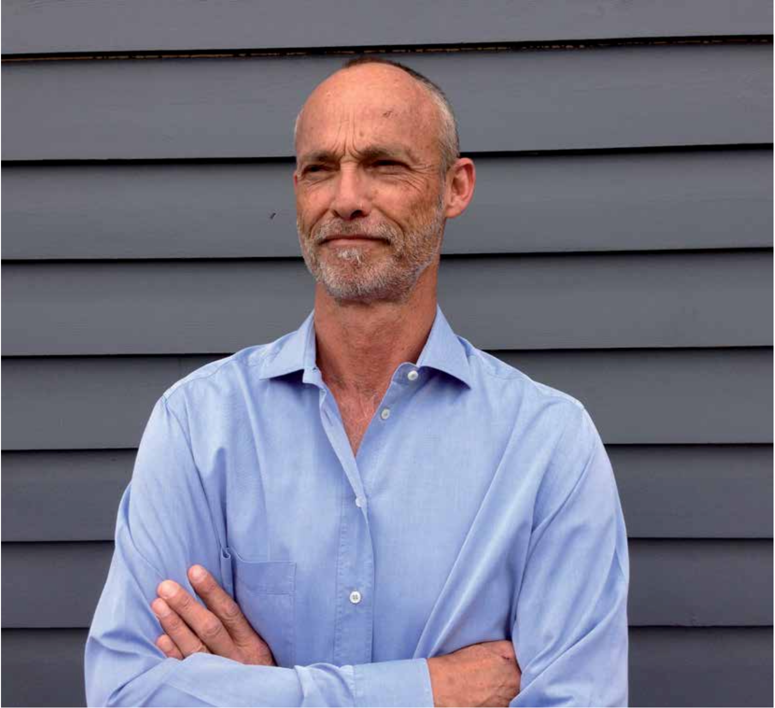

There's nothing like the pain of financial loss to hardwire your pain- pleasure receptors to be more alert.
TraDer'S STory

more inclined to take on bigger risks.) I was working for Dow Jones, educating clients on technical analysis and money management rules, so I should have known better. I did know better. It hurt. It was the textbook ‘ego trade’. Rule number one in trading – never ever average a loser!
uncanny ability to sniff out a ‘frothy’ market. We might think we understand what greed looks like, but even the best of us can get caught up in the emotions of calling tops and getting involved in market bubbles. It’s also why it’s important to have a system that alerts you to these problems early. My old
10. What advice would you offer to people getting started as traders on the relative merits or otherwise of each? Build your trading system on a proven edge. Protect yourself by using basic money management principles. And perhaps the most challenging rule of all: implement your system!

To use a familiar trading adage: I ride the winners and cut the heads off the losers quickly. The more I've learnt, the simpler my approach has become.

5. Would you define yourself as a discretionary or mechanical trader, or a combination of both?
Mechanical with a small discretionary component.

6. Can you give us a brief overview of your trading style?
First of all, I never use leverage. There are plenty of opportunities to make money; no need to take on more risk. I use a systematic market timing approach that gives me an edge in buying low and selling high. There are three basic components to this system. I only buy stocks with emerging up trends. I only trade weekly, which reduces the noise, as well as the number of trades and cost. And I use a predetermined trailing stop-loss to exit all my positions. To use a familiar trading adage: I ride the winners and cut the heads off the losers quickly. The more I’ve learnt, the simpler my approach has become. There is no end to the amount of research you can do when analysing stocks. There are hundreds of technical indicators, for instance, and dozens of chart patterns. And each trader will have a slightly different take on each and every one of them. Best to focus on what actually works.

7. Is there any one trade (win or loss) that had a profound effect on your development as a trader? If so, what did you learn from the trade?
Yes, it was actually a trade my father had in RIO and NWS. He has always had an
man is the rare kind who has this system in- built. He sold NWS at a major top in March
2000, and more recently RIO, at $125, before the crash. The lesson: do what you think is right and ignore the noise. It’s what gave me the confidence to advise my clients to exit
95% of stocks pre-GFC, which wasn’t a popular move at the time, but proved to be the right one.

8. Can you tell us about your best and worst trades?
GOOD ONE: Bought JBH in 2004 and sold it in 2007, for a 400% rise. Bought it again in 2008, and sold it in 2009, for a run-up of around 100%. Ride your winners! My trailing stop-loss rule was key; it kept me in these big winning positions for far longer than a discretionary approach would have. It’s the difference between large portfolio returns and average ones.
BAD ONE: A long overnight gold position that went underwater quickly. I then averaged down – ‘the ego trade’ – and it went from bad to worse. It was psychologically damaging. I was living in London at the time, younger and more foolish. Cut those losses quickly using a cold-hearted systematic approach. Trust me, the short-term pain will be replaced by long-term psychological strength and satisfaction.

9. Would you classify yourself as a short-term or long-term trader?
Mid to long-term.
11. What markets do you trade and which markets do you prefer? Do you have a favourite and why?
Australian equities. I like to take advantage of the long-term uptrend in equities, which is an important edge to have. Currencies, for instance, do not display this one-way component. I don’t short stocks for the same reason, as the odds are less advantageous in the long run. Best to sit on your hands, and keep your powder dry for better opportunities down the road. Many Australian companies also pay great dividends.
You should also stick to what you know
– if you can’t get it right where you are, diversifying into other markets, such as currencies and commodities, won’t help. Your trading principles have to be right.

12. What makes your trading style different from others? What sets you apart from other traders?
I follow a system that works. I don’t think I know better. The human component can be damaging and hurt your bottom line. My motto is: focus, discipline and confidence in your plan, and having clients looking over your shoulder making sure you don’t stray from it. You must be accountable to someone, be it your boss, your clients, or your wife.

13. Do you have a favourite rule?
My exit rules. When you’re wrong, because your system tells you are, get out! It’s my single greatest money saver. It knows better.

The market challenges me to be better than I am – as a trader and as a human being. Doing what is right in the long run and not necessarily what I want to do at the time.

14. Ed Seykota says, "Everybody gets what they want from the markets." What do you get from the markets? The stock market doesn’t stop challenging me. It’s an inner game, as well as an outer one. The market challenges me to be better than I am – as a trader and as a human being. Doing what is right in the long run and not necessarily what I want to do at the time. That’s the biggie.

15. Has trading affected your lifestyle? It’s allowed me to be my own boss, which has been hugely rewarding. I live by the beach in Melbourne. I walk to work, often in shorts and a T-shirt. It’s also taught me contentment, to be happy with what you’ve
got. The need to have more, to risk more, to be George Soros, no longer holds me. My smaller and safer game is enough. Don’t let greed derail your real long-term goals.

16. What books, seminars to courses have you read and attended and which would you recommend?
Nicholas Darvas’s autobiographical book from 1961, How I made $200,000 in the stock market. Argh the inspiration! The simplicity!

17. What does the future hold of you? Security, because investors don’t need to be exposed to GFC events. They are easily avoidable. YTE

